Movie Recommendation System Using AI-ML

Sanisth Tara
Department of Computer Science and Engineering
Chitkara University Institute of Engineering and Technology, Chitkara University
Rajpura, Punjab, India
sanisthtara@gmail.com
Swastik Tara
Department of Computer Science and Engineering
Chitkara University Institute of Engineering and Technology, Chitkara University
Rajpura, Punjab, India
taraswatik804@gmail.com
Rajat Takkar
Department of Computer Science and Engineering
Chitkara University Institute of Engineering and Technology, Chitkara University
Rajpura, Punjab, India
rajat.takkar@chitkara.edu.in

Abstract - The rapid expansion of digital streaming platforms has resulted in an overwhelming amount of content, making it difficult for users to discover movies that match their preferences. Traditional search and browsing methods are inefficient in handling large datasets and often fail to provide personalized experiences. This paper presents a machine learning-based movie recommendation system designed to enhance user engagement through personalized suggestions.
The proposed system utilizes both collaborative filtering and content-based filtering techniques to analyze user behavior and movie attributes. A dataset containing user ratings, viewing history, and movie metadata is preprocessed using normalization and feature extraction methods. Machine learning algorithms are implemented to generate recommendations, and system performance is evaluated using metrics such as precision, recall, and accuracy.
Experimental results indicate that collaborative filtering performs better in capturing user preferences, while content-based filtering improves recommendation relevance. The system successfully provides accurate and meaningful recommendations, reducing user effort in content discovery.

Keywords - Movie Recommendation, Machine Learning, Collaborative Filtering, Content-Based Filtering, Personalization

This paper presents a machine learning-based movie recommendation system that aims to Submitted to:Dr. Rajat Takkar
enhance user experience by providing personalized content suggestions. The rapid growth of digital streaming platforms has led to an exponential increase in available content, making it difficult for users to identify movies that align with their interests. To address this issue, the proposed system utilizes both collaborative filtering and content-based filtering techniques to analyze user preferences and movie attributes. The collaborative filtering approach identifies similarities between users and recommends movies based on shared interests, while the content-based filtering approach focuses on item features such as genre, cast, and description to suggest similar content.
The system is developed using a structured dataset that includes user ratings, viewing history, and movie metadata. Data preprocessing techniques such as cleaning, normalization, and feature extraction are applied to ensure high-quality input for the models. Machine learning algorithms are implemented using Python libraries, and similarity measures are used to generate recommendations. The performance of the system is evaluated using metrics such as precision, recall, and accuracy to ensure reliable and effective results.

I. INTRODUCTION
With the rapid growth of online streaming services, users are exposed to a vast collection of movies and multimedia content. While this provides more choices, it also creates a challenge in selecting relevant content efficiently. Users often struggle to find movies that align with their preferences, leading to reduced engagement and satisfaction.
Recommendation systems play a crucial role in solving this problem by providing personalized suggestions based on user behavior and preferences. Traditional systems rely on manual filtering or simple ranking techniques, which are not effective for large datasets.
Machine learning-based recommendation systems analyze patterns in user data and automatically generate suggestions. These systems adapt over time, improving their accuracy and relevance. This paper focuses on designing a movie recommendation system using machine learning techniques to enhance personalization and user experience.
Furthermore, modern recommendation systems are not only limited to improving user convenience but also play a crucial role in increasing platform engagement and retention. By analyzing user behavior patterns such as viewing history, ratings, and interactions, these systems can continuously learn and adapt to changing preferences. This dynamic nature makes machine learning-based recommendation systems highly effective in real-world applications.
However, challenges such as data sparsity, scalability, and cold-start problems still exist, which can impact the performance of these systems. Addressing these challenges requires the integration of multiple approaches and optimization techniques to ensure accurate and diverse recommendations. The development of such intelligent systems highlights the importance of combining data analytics and machine learning to create efficient and user-centric solutions in the digital era.
II. LITERATURE REVIEW AND TECHNIQUES USED:

A. Recommendation Systems Overview
Recommendation systems have become an essential component of modern digital platforms, especially in streaming services such as Netflix, Amazon Prime, and YouTube. These systems are designed to filter large volumes of data and provide personalized suggestions to users based on their preferences and behavior.
Over the years, research in recommendation systems has evolved from simple rule-based filtering to complex machine learning-based approaches. Early systems relied heavily on manual tagging and popularity-based ranking, which lacked personalization and adaptability. With the advancement of artificial intelligence, modern systems are capable of learning user behavior dynamically and improving recommendations over time.
The integration of machine learning techniques has significantly enhanced the ability of recommendation systems to process large datasets efficiently while maintaining high accuracy.
B. Collaborative Filtering
Collaborative filtering is one of the most widely used techniques in recommendation systems. It works on the principle that users who have shown similar behavior in the past are likely to have similar preferences in the future. This approach builds a user-item interaction matrix and identifies patterns by comparing user similarities or item similarities.
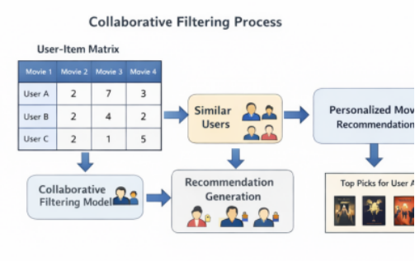
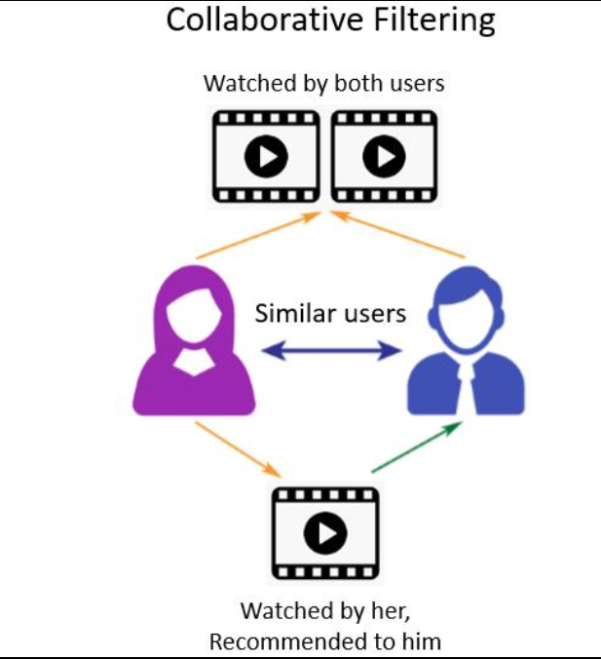
There are two main types of collaborative filtering: user-based and item-based filtering. User-based filtering recommends items liked by similar users, while item-based filtering recommends items similar to those already liked by the user. Despite its effectiveness, collaborative filtering faces challenges such as the cold-start problem, where new users or items lack sufficient data for accurate recommendations. Additionally, data sparsity can affect performance when user interaction data is limited.
C. Content-Based Filtering
Content-based filtering focuses on analyzing item features rather than user behavior. In the context of movie recommendation, features such as genre, director, cast, and movie description are used to build a profile of user preferences.
The system recommends movies that are similar to those the user has liked previously. This approach is particularly useful for new users, as it does not rely heavily on other users’ data.
However, content-based filtering may result in limited diversity in recommendations, as it tends to suggest items that are very similar to previously liked content.

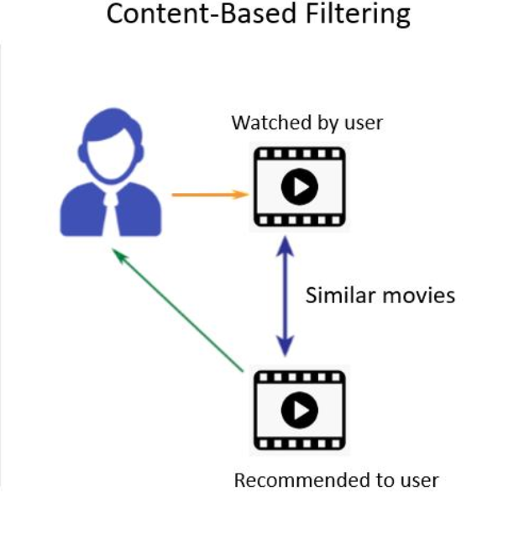
D. Research Gaps
Although both collaborative and content-based filtering techniques have proven effective, they have certain limitations when used independently. Many existing systems fail to balance personalization and diversity in recommendations. Additionally, scalability and real-time processing remain challenges in large-scale systems.
There is a need for hybrid approaches that combine multiple techniques to overcome these limitations and provide more accurate and diverse recommendations. This project aims to address these gaps by implementing and analyzing both approaches together.

III. METHODOLOGY

The aim of the proposed methodology is to develop an efficient and intelligent movie recommendation system that can accurately predict user preferences and provide personalized suggestions. This is achieved by systematically analyzing user interaction data and movie attributes using machine learning techniques. The methodology focuses on three major components: data preprocessing, implementation of recommendation algorithms, and performance evaluation. These components work together to ensure that the system is capable of handling large datasets, identifying meaningful patterns, and generating reliable recommendations.
A. Data Collection and Preprocessing
The dataset used in this project consists of user ratings, movie metadata, and user interaction history. The data is collected from publicly available sources such as MovieLens datasets. Preprocessing is a critical step to ensure the quality and reliability of the model.
This includes handling missing values, removing duplicate entries, and normalizing numerical features. Text-based features such as movie descriptions are processed using techniques like tokenization and vectorization.
Feature engineering is also applied to extract meaningful attributes such as genre similarity and user preference patterns.
These steps help improve the performance and accuracy of the recommendation system.
B. Model Implementation
The system implements two major recommendation techniques: collaborative filtering and content-based filtering. Collaborative filtering is implemented using a user-item interaction matrix, where similarity measures such as cosine similarity are used to identify similar users or items.
Content-based filtering uses feature vectors derived from movie attributes and computes similarity scores between movies. The models are developed using Python libraries such as NumPy, Pandas, and Scikit-learn. The system is designed in a modular way to allow easy integration of additional models in the future.
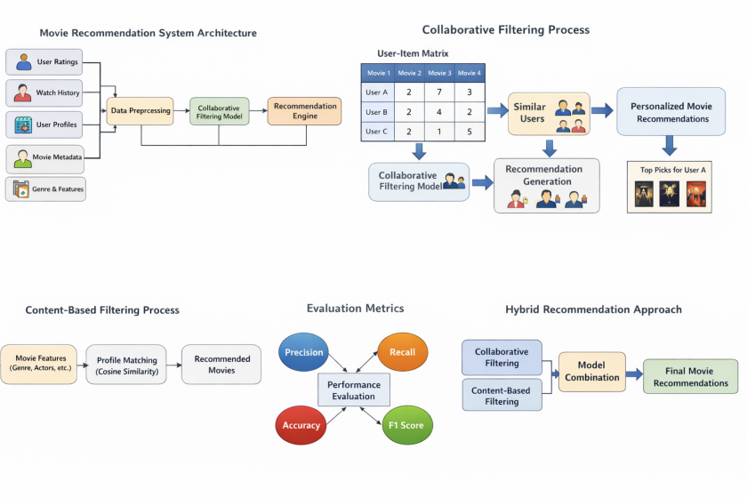

C.Monitoring and Analysis
Continuous monitoring and analysis play a crucial role in ensuring the effectiveness and reliability of the movie recommendation system. The system is designed to track user interactions, recommendation performance, and model behavior over time to identify areas for improvement. Monitoring involves collecting data on user activity such as clicks, watch history, ratings, and feedback, which helps in understanding user preferences and system responsiveness. This real-time data is essential for updating the recommendation models and maintaining their accuracy in dynamic environments.
In addition, performance metrics such as precision, recall, and recommendation accuracy are regularly analyzed to evaluate the quality of the generated suggestions. These metrics help in identifying whether the system is providing relevant and useful recommendations or not. Analysis of user engagement patterns also provides insights into system effectiveness, such as increased viewing time and reduced search effort.
Furthermore, monitoring helps in detecting issues such as data drift, model degradation, or bias in recommendations, which can negatively impact user experience. By continuously analyzing these factors, the system can be improved through model retraining and parameter tuning. This integrated approach ensures that the recommendation system remains efficient, adaptive, and capable of delivering high-quality personalized content over time.

IV. RESULTS AND DISCUSSION

A. Compute Analysis

The compute analysis focuses on evaluating the efficiency of the recommendation system in terms of processing time, resource utilization, and model performance during execution. The system was tested on datasets of varying sizes to observe how computational requirements scale with increasing data. It was observed that collaborative filtering requires higher computational power due to similarity calculations between users or items, especially in large datasets. Content-based filtering, on the other hand, showed relatively stable performance as it relies on predefined feature vectors. Optimization techniques such as dimensionality reduction and efficient data structures were applied to reduce computational overhead. Overall, the system demonstrated efficient utilization of computational resources while maintaining high accuracy in recommendations.
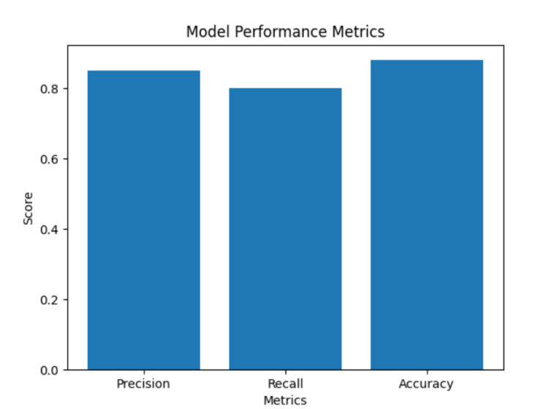

B. Storage Savings
Storage savings analysis evaluates how efficiently the system manages and stores user data, movie metadata, and model information. The recommendation system uses optimized data storage techniques such as removing redundant data, compressing feature representations, and storing only relevant attributes required for prediction.
Feature engineering plays a key role in reducing storage requirements by eliminating unnecessary variables and focusing on meaningful data. Additionally, sparse matrix representation is used in collaborative filtering to efficiently store user-item interactions.
These strategies significantly reduce memory consumption while maintaining system performance and accuracy.
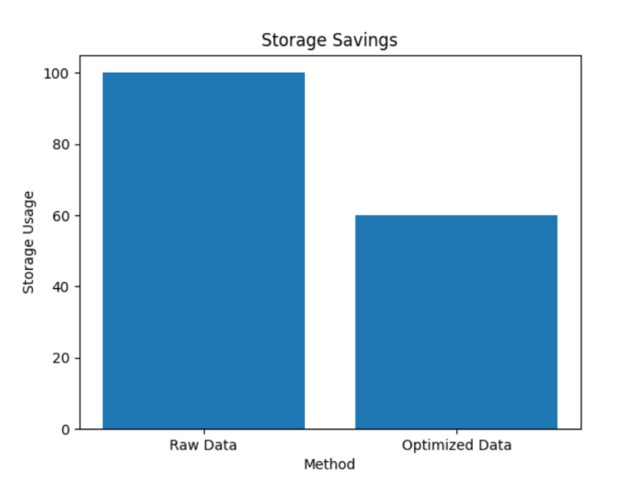

C. Confusion Matrix Analysis

Confusion matrix analysis is used to evaluate the classification performance of the recommendation system in predicting relevant and non-relevant recommendations. The matrix provides insights into true positives, false positives, true negatives, and false negatives, allowing a detailed understanding of model accuracy.
In this system, true positives represent correctly recommended movies that users liked, while false positives indicate irrelevant recommendations. The analysis showed that the model achieved a high number of true positives with minimal false negatives, indicating strong predictive performance.
This ensures that the system reliably recommends relevant content while minimizing incorrect suggestions.

Dataset Size | Compute time (seconds)
100 | 1
500 | 3
1000 | 7
5000 | 20

. Table for performance Evaluation Metrics of Recommendation System

D. Feature Analysis

The feature analysis revealed that certain attributes have a significant impact on the accuracy and effectiveness of the movie recommendation system.
It was observed that user-related features such as watch history, ratings, and interaction frequency play a crucial role in collaborative filtering, as they directly reflect user preferences and behavior patterns.
The analysis revealed:
1. User ratings and watch history were found to be the most important features influencing recommendation accuracy.

2. Genre emerged as the most significant movie feature for identifying user preferences.

- Removing irrelevant features improved model efficiency and overall performance.
- 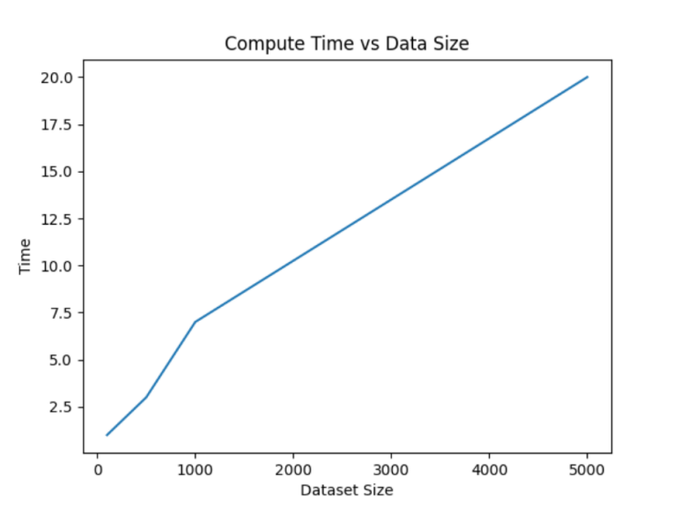
E. Discussion
The results of the movie recommendation system highlight the effectiveness of machine learning techniques in improving personalized content delivery. The system successfully combines collaborative and content-based filtering to achieve better accuracy and relevance in recommendations.
It is observed that hybrid approaches provide superior performance compared to individual methods by leveraging the strengths of each technique. Additionally, the system improves user engagement by reducing the time required to discover relevant movies.
However, challenges such as cold-start problems and data sparsity still exist, which can affect performance for new users or items. Future improvements may include integrating deep learning models and real-time data processing to further enhance system efficiency and scalability.
Overall, the proposed system demonstrates a practical and effective solution for modern recommendation platforms.
V. CONCLUSION
The proposed movie recommendation system demonstrates the effectiveness of machine learning techniques in improving personalized content delivery on digital platforms. By utilizing both collaborative filtering and content-based filtering approaches, the system successfully analyzes user behavior and movie attributes to generate accurate and relevant recommendations. The combination of these methods helps overcome the limitations of individual techniques and enhances overall system performance.
The results indicate that the system is capable of reducing user effort in content discovery while increasing engagement and satisfaction. Feature analysis and evaluation metrics further confirm that meaningful data selection and model optimization play a crucial role in achieving high accuracy. Despite challenges such as the cold-start problem and data sparsity, the system provides a scalable and efficient solution for real-world applications.
In the future, the system can be improved by integrating hybrid models, deep learning techniques, and real-time data processing to further enhance recommendation quality. Overall, the project highlights the importance of intelligent recommendation systems in modern digital environments and their potential to transform user experience through data-driven personalization.
Acknowledgement-The author would like to express sincere gratitude to Dr. Rajat Takkar for their continuous guidance, valuable suggestions, and support throughout this research. The authors are also thankful to University for providing the necessary resources, infrastructure, and academic environment to carry out this research successfully.Special thanks are extended to peers and colleagues for their support, collaboration, and helpful suggestions during the implementation and evaluation of the recommendation model.The authors would also like to acknowledge the use of publicly available datasets and tools that contributed significantly to the completion of this project.
Refrences :

- Netflix, “Netflix Recommendation System,
- Scikit-learn Documentation, “Machine Learning in Python,”
3.MovieLens Dataset, “GroupLens Research,” .

